**Emergency Ventilator**

Functional specification

Issue/change record

|  |  |  |  |
| --- | --- | --- | --- |
| Issue | Date | Author | Reason of issue/summary |
| 0.A | 10/04/2020 |  | DRAFT, released for ongoing development |
| 0.B | 15/04/2020 |  | Typo and error corrections. 2.1.3 flow chart revised. |
|  |  |  |  |
|  |  |  |  |
|  |  |  |  |
|  |  |  |  |

Contents

Introduction 3

1 Pressure Controlled SIMV 3

2 Functional specification 3

2.1.1 User interface 3

2.1.2 Schematic diagram 6

2.1.3 Ventilator operation flow chart 6

2.1.4 Pressure waveform specification 8

2.1.5 Alarm signals 9

2.1.6 Components 10

2.1.7 Critical parts 12

2.1.8 Electronic design 12

2.1.9 Firmware flow – Level 1 – flow chart 14

2.1.10 Firmware flow – Level 2 – psudo code 14

2.1.11 Firmware flow – Level 3 – source code 15

2.1.12 Software bug register 15

2.1.13 Labelling 15

2.1.14 Durability of markings 16

2.1.15 Packaging 16

2.1.16 Clinical procedure 16

Appendix 1 – Bill of Materials 18

Appendix 2 – Source code 20

# Introduction

This document contains the full concept hardware and software design. The design is intended for the 75% of intensive care beds that are yet to be established in makeshift facilities.

# Pressure Controlled SIMV

For purpose of simplicity, the ventilator operates in conventional Pressure Controlled SIMV (Synchronised Intermittent Mandatory Ventilation) mode of ventilation only. The ventilator will secure a set number of breaths per minute, by firstly attempting to synchronize the mechanical delivery of breaths with patient’s spontaneous efforts. If the patient fails to spontaneously take a needed breath, then the ventilator delivers it mandatorily.

To prevent a ‘fight’ between the patient and the ventilator, the ventilator reschedules the mandatory breath that follows a successfully synchronized spontaneous breath by 1 second.

SIMV behaves as PSV (Pressure Support Ventilation, including with reduced IP during weaning) when the patient makes full efforts, and it behaves as CMV (Continuous Mandatory Ventilation) if the patient does not make any efforts. When used with a mask on a conscious, spontaneously breathing patient, the SIMV behaves as nPSV or Synchronised BiPAP (by setting IP low). Switching the IP cycle off (or setting it equal to PEEP) makes SIMV behaves as CPAP (whether the patient is intubated or has a mask interface).

# Functional specification

This section describes how the required performance characteristics (see General Description) are met.

### User interface

The user interface is very simplified (and somewhat industrial looking). The top half of the facia is the monitoring interface. The bottom half is the controlling interface.

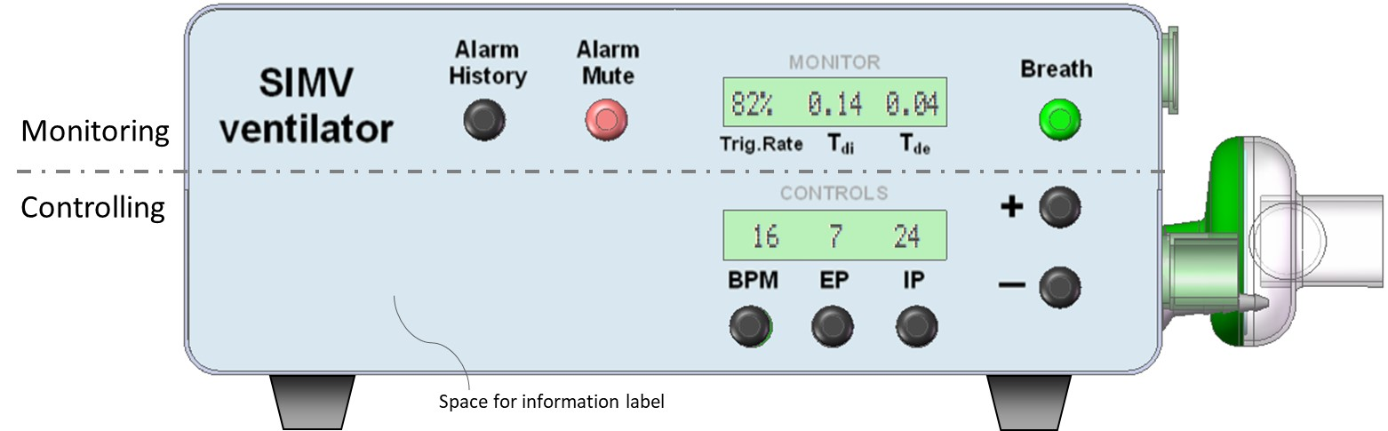

The process for adjusting a control paraments:

1. Press parameter control button.
2. Observe that the parameters value starts flashing (will time out after 5 sec inactivity).
3. Adjust the flashing parameter value using the +/- buttons.
4. Press parameter control button again to confirm the new setting.

The ‘Breath’ button has an integral green light. This flashes for 0.5s every time a spontaneous breath is detected. This provides an at a glance status of the patient, which can be seen at a distance across a room.

Pressing the green ‘Breath’ button delivers a manual breath. This is used to re-recruit the lung following a procedure that temporarily disconnected the patient from the ventilator, such as during suctioning or while changing the FiO2 level.

The ‘Alarm Mute’ button has an integral red light, which flashes under an alarm condition. Pressing the button will cancel the alarm event and suspend further alarms for 120 seconds.

The ‘Alarm History’ cycles through the last 10 alarm messages.

Alarm messages appear in the monitor (top) LCD display, where they overwrite the monitored parameters from 2.5 seconds every 3 seconds – i.e. the monitored values flash up for 0.5 seconds every 3 seconds while an alarm message is displayed.

The alarm message ‘Monitor Fail’ is detected by the controller and is displayed in the lower LCD.

Hospital staff commonly write information or place labels on their medical equipment, such as giving the device an identifiable name or number, or placing a reminder label. The facia is given a space for this. Below is an example reminder label that may be useful for certain personnel – without crowding the facia and detract from its simplicity.

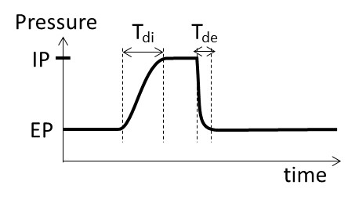

To power up the ventilator, press the ‘ON/OFF’ switch on the rear. Observe the power-up self-test correctly displays LEDs and the display digits.

To power down the ventilator, press the ‘ON/OFF’ switch on the rear. The monitor will display a message for 5 seconds saying ‘Power OFF?’. During this short period, press and hold any of the facia buttons for 2 seconds. If the 5-second message is missed, then simply flick the ‘ON/OFF’ switch again, to restart the 5-second message.

If none of the buttons are held for 2 seconds, or just pressed momentarily, the message will disappear and the ventilator will continue to operate under battery power. This enables moving the patient or intra-hospital transport.

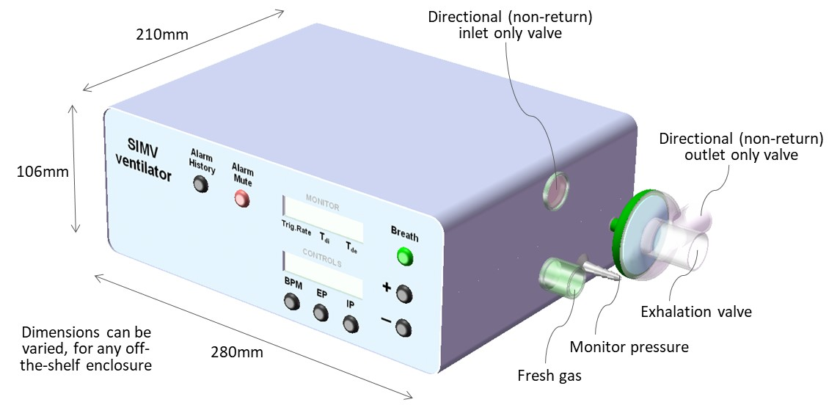

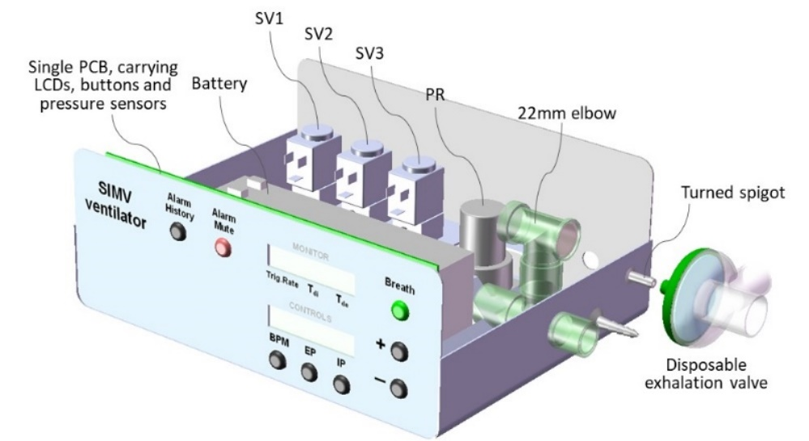

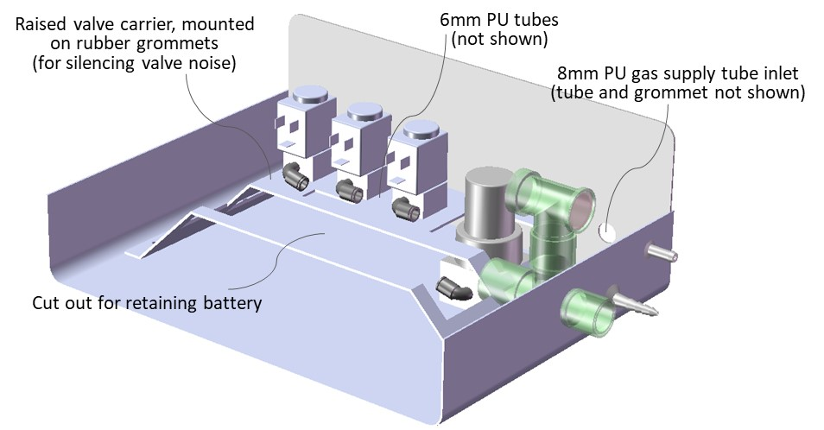

### Schematic diagram

The Monitor and Controller operate independently, in parallel, observing each other (watchdogs). This assures the detection and alarming on any single failure mode. Both the controller and the monitor are capable of detecting an excess pressure (>40 mbar) and each can shut down the supply gas. The circuit pressure is immediately relived through the exhalation valve. This duality safeguards that compressed gas does not reach the patient circuit. All valves are NC (normally closed) types and will default to shutting off gas supply in case of total (battery) power failure.

The Controller operates its own user interface, for adjusting the parameters (BPM, EP and IP). The Controller reports its 3 parameters values every 50mS across an I2C serial interface with the Monitor. The Controller also reports when a valid change is made via the user interface. If the Monitor does not acknowledge receipt, then the Controller will instigate an alarm.

If the Controller reported ventilator paraments changes, without a prior valid user change, then it would indicate the Controller memory has corrupted. The Monitor will then alarm and can shut down gas supply if hazardous conditions occur.

The Monitor also calculates the triggered breath rate (patient effort) and the wave rise/decay times (Tdi and Tde, which indicates lung/system status). It will alarm if these deviate from tolerances.

On shut-down, the patient can breathe ambient air through the 2 directional NR valves.

[is the flow sensor implemented? Then show]

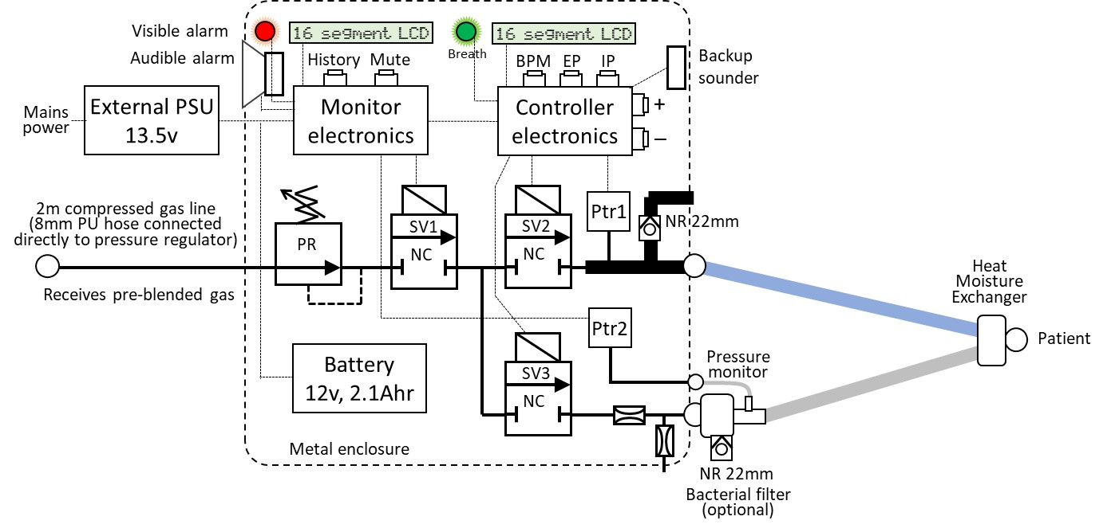

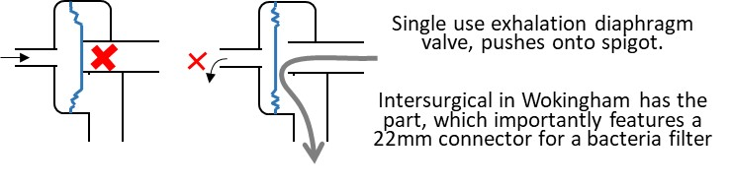

### Ventilator operation flow chart

The Controller cycles the pressure wave in accordance with the set parameters (BPM, EP and IP). The inspiration cycle is instigated on breath detection, or if the mandatory cycle time is reached.

‘Open SV3’ has the effect of closing the exhalation valve – i.e. it should be read as ‘close exhalation valve’.

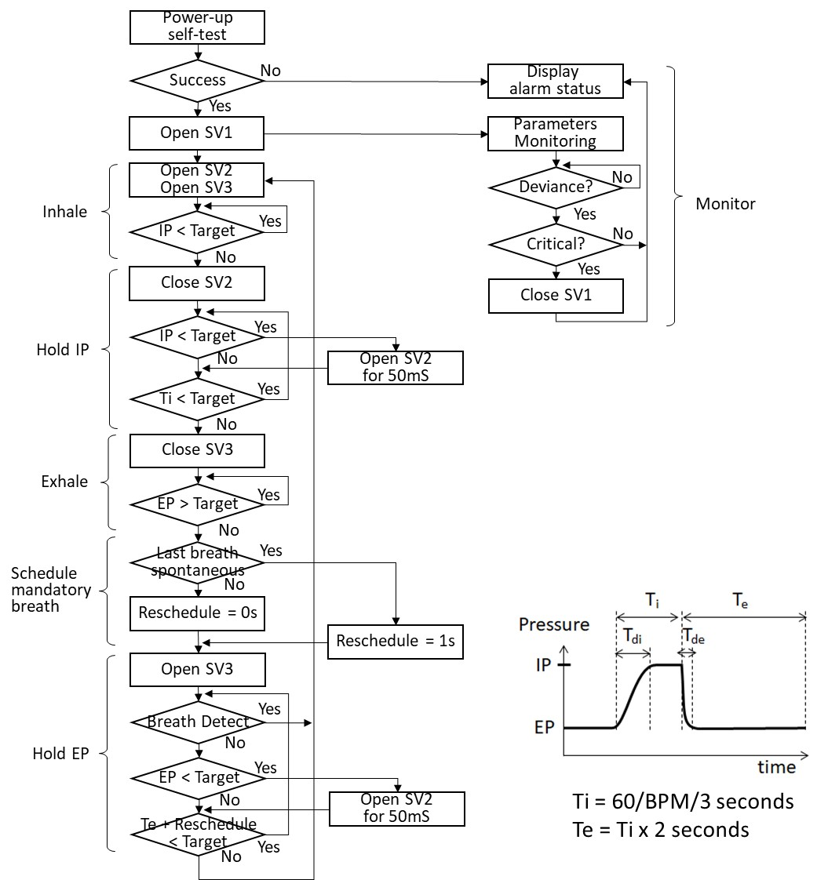

The steps ‘IP < Target’ and ‘EP > Target’ are likely to result is a small overshoot if implemented in their simplest form, due to the solenoid valve inertia/response time. The step will likely have some sub-steps to compensate for this, for example:

1. One approach: Once the ventilator user sets a new Target the initial breath cycle will use ‘IP < Target x 95%’. If this first breath undershoots, then the next cycle can be increased to ‘IP < Target x 96%). Keep incrementing until the intended IP is met and then freeze this setting. Do the same in reverse for reaching EP. The first cycle might use ‘EP > Target x 105%’ and then decrement this correction factor. Freeze the correction factor once the intended EP is reached. It could take 2 or 3 breaths for the ventilator to settle the IP and EP after a setting is changed.
2. Another approach, is to use testing and understanding of the overshoot and then build a fixed correction value into the software – i.e. the final compensation is applied to the very first breath cycle. A small variance can creep in if the IP rise time (Tdi) or EP decay time (Tde) changes/drifts, or if different solenoid orifice sizes are introduced. Such a small variance might be within tolerance and considered accurate enough. If not, the solution a) above is better at responding to the dynamics in the patient and circuit conditions.

The steps ‘Open SV2 for 50mS’ tops-up the patient circuit pressure, to compensate for leak in nSIMV/SyncBiPAP/CPAP with mask. In mask mode, this is will create a harmless ripple on the pressure plateaus. In fact, in HFOV and Bubble CPAP ventilation in infants, such type of pressure ‘vibration’ is reported to improve alveolar gas diffusion (makes ventilation more efficient).

The top-ups will not normally happen with an intubated patient, unless the circuit is incorrectly connected/faulty. The ventilator would indicate that top-ups are happening – hence, indicating a potential patient circuit problem.

In mask ventilation, the breath detection algorithm needs to discriminate between the patient breath effort and a top-up ‘ripple’. The former manifests as a small pressure drop, while the latter manifests as a small pressure rise – i.e. they are different and detectable, until they occasionally collide. Possibly, under large leak conditions, the breath detection sensitivity will have to be lowered, to prevent false triggers. Fortunately, mask ventilation is used primarily with strong breathing patients.

When making EP and IP the same value (showing IP as ‘OFF’), the ventilator is effectively in CPAP more and the IP steps can be by-passed. When the then patient breathes in, the pressure in the circuit reduces and SV2 will compensate by pulsing in fresh gas. When the patient subsequently exhales, the pressure in the circuit increases and valve SV3 will deactivate to exhaust the exhaled gas. This routine secures minimal gas/oxygen consumption in CPAP and BiPAP modes (contrary to conventional devices, which maintain about 15L/min continuous flow).

### Pressure waveform specification

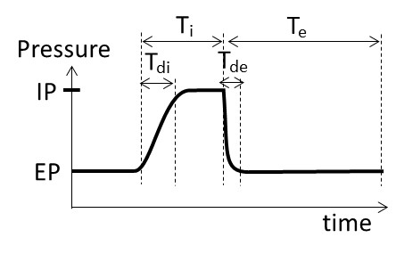

Ti (inspiratory time) varies between 0.7s (at 30 BPM) and 2s (at 10 BPM). Te (expiratory time) is 2 times Ti, according to the fixed 1:2 I:E ratio.

The ideal Tdi (inpspiratory pressure rise time) is about 0.3s, or 1/3 of the Ti, when ventilating a patient lung. Extending it to 0.45s would be tolerated and might make valve timing control easier. This equates to 60L/min inspiration flow rate. The natural inertia in the breathing circuit volume creates a natural softer starting flow rate. Beware if using a test lung with different compliance (e.g. a 5L plastic bottle) the Tdi will differ.

Tde should be as short as practically possible. The actual Tde depends on the lungs natural elasticity and resistance in the breathing circuit. As long as it looks reasonable sharp then the CO2 washout will happen.

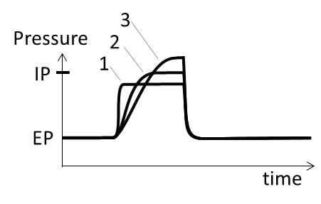

The rationale for Tdi is illustrated by the 3 waveform examples above. Each the 3 waves deliver about the same amount of ‘work’ and fill the lung with an equivalent volume of gas.

#1 uses the least pressure (which is good), but the abrupt rise is faster than the lung can comply. This risks putting shear stress on the lung tissue.

#3 produces a gentler rise (which is good), but it requires a higher plateau (which is bad) because the lung tissue is sensitive to pressure (barotrauma).

#2 is the best compromise. The plateau should ideally be about 2/3 of the Ti time, but should be compromised to 60L/min flow rate. With the fastest Ti being 0.67s, the best fixed Tdi = 0.45s.

A 5L plastic bottle test lung tends to be less compliant and fills more straightforwardly (compared to the intricate lung). Development testing should probably focus on Tdi = 0.2s. Tdi is adjusted by regulator PR, or by changing the orifice size in SV1 and/or SV2 (preferably they are kept the same).

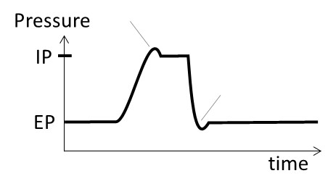

Small over-/under-shoot spikes are tolerated, but undesirable. An IP overshoot larger than 3 mbar is not tolerated. There are actually special modes of ventilation that has a lower IP plateau combined with a larger overshoot, and there are modes that deliberately undershoot the initial EP plateau (to help CO2 washout). However, these are specialist modes and not should be default in an emergency ventilator.

Lastly, it is one thing to re-produce the pressure waveform. It must be simultaneously assured that inhaled gas comes from the fresh supply side and that exhaled gas is entirely directed into the exhaust path. The patient must not rebreathe the same gas, which would become increasingly oxygen depleted and CO2 enriched (results in suffocation). Many ventilators have a continuous flush flow through the circuit; but this is omitted in this design, to preserve oxygen (in short supply).

### Alarm signals

The signals are specified by international standard IEC 60601-1-8. The priority level is assigned according to the following table from the standard:

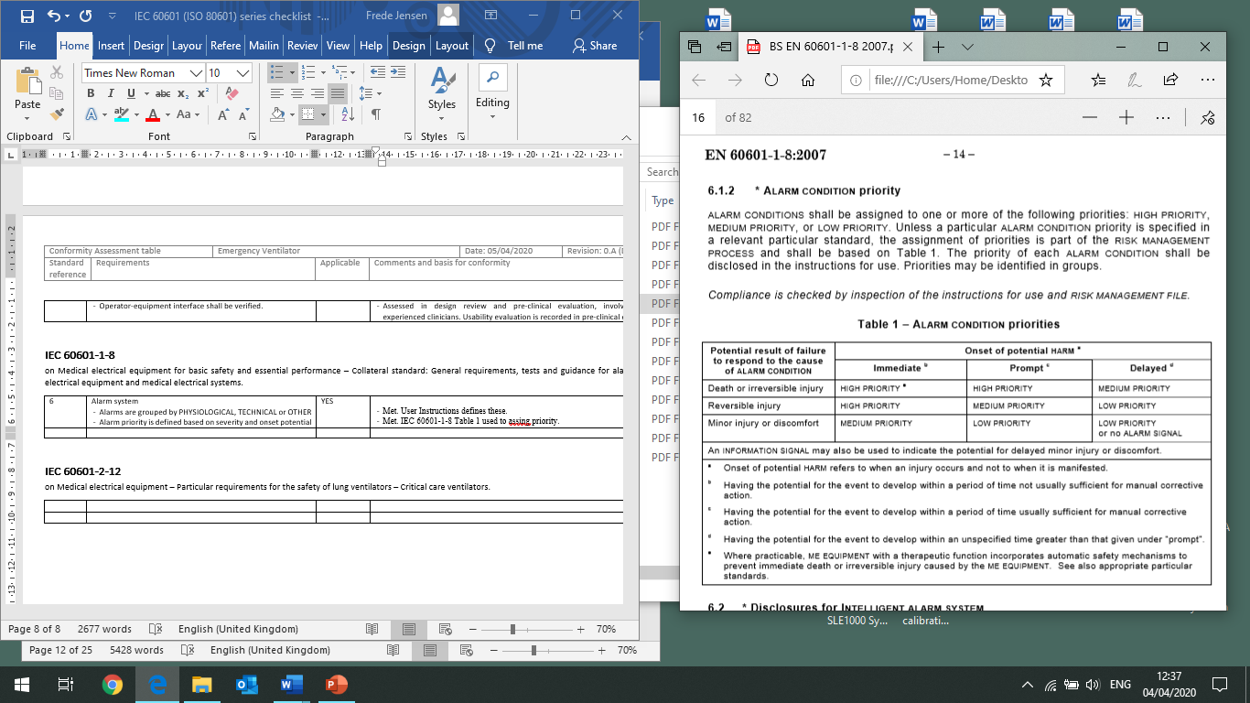

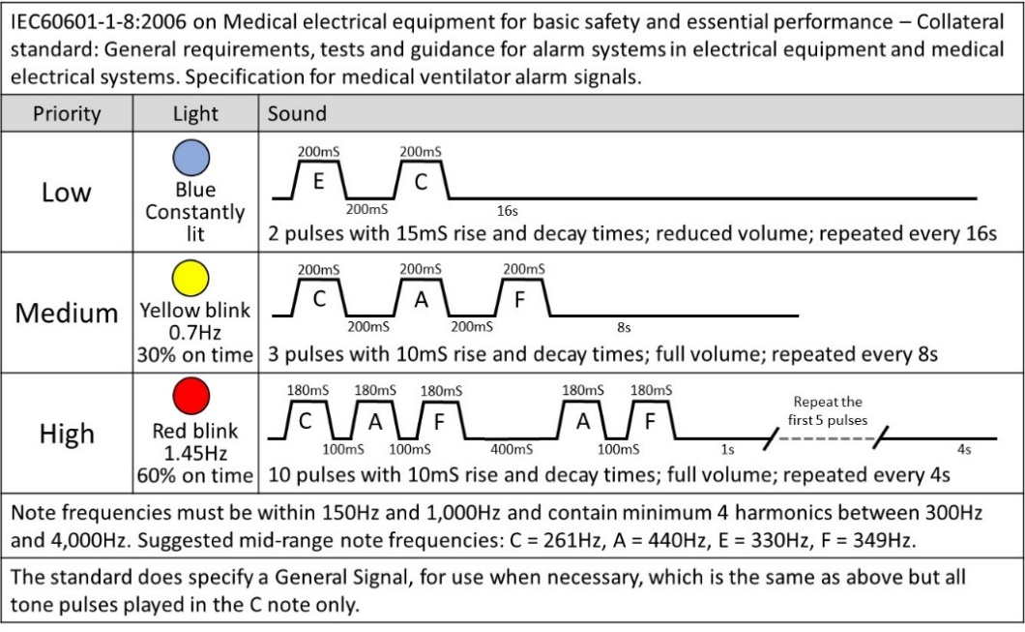

It is acceptable for an emergency ventilator to deviate from the standard. The alarm sounder in this design conforms to the standard pulse lengths, but it will be played in a single tone – aligning to the ‘general’ tone specified in the standard (although not the tone rise/decay) – i.e. it plays the correct melody, but in just one note. This simplifies construction and the development time.

It is proposed to use a single colour alarm light, but to pulse it in compliance with the standard.

### Components

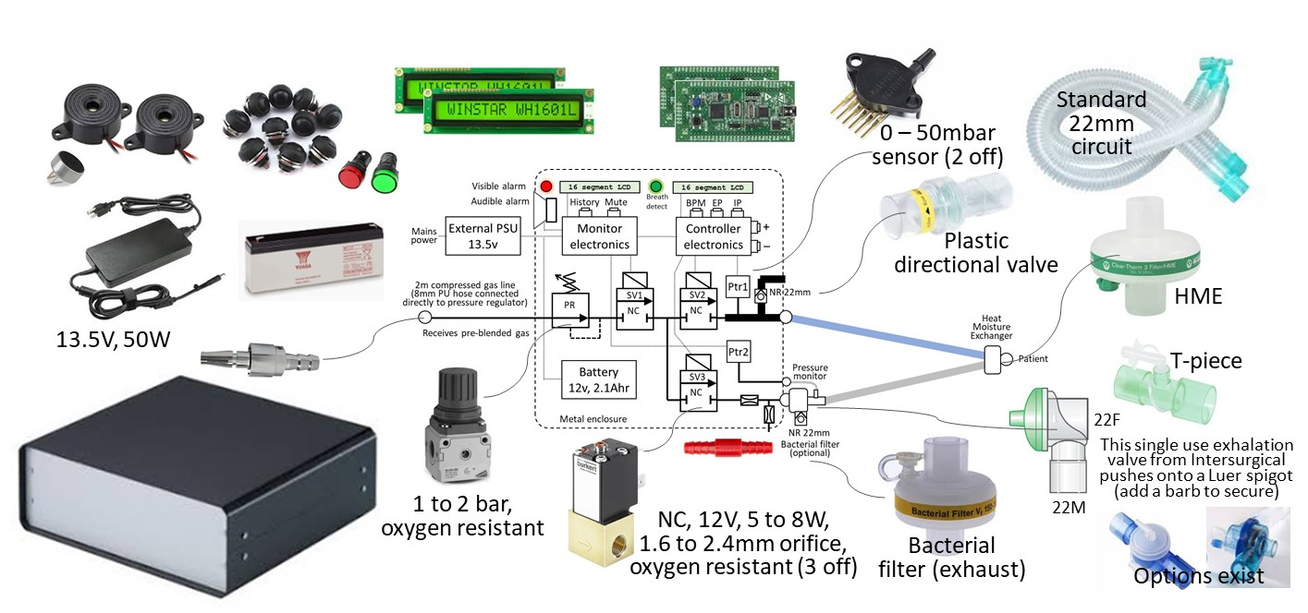

All components are available off-the-shelf at most national levels. **Total components cost for the ventilator are approximately £400 (GBP), or Eu460 or US$500. Each patient circuit has a component cost of £12 (GBP), at trade prices.** The Bill of Materials is included in Appendix 1.

Components are selected for having known acceptable electro-magnetic characteristics in other applications (to enable omission of time-consuming EMC qualifications).

The design is highly tolerant to alternative brands and specification variances. For example:

* The pressure regulator can be any brand that is oxygen resistant and is adjustable between 1 and 2 bar (15 and 30psi), while being stable. Possibly a relieving type is most stable, but a non-relieving can be acceptable. The low cost (£14) type shown above is fine. Small and cheap (£8) regulators (the type measuring less than 15mm across) tend to be less stable and are likely unsuitable.
* The solenoid valves simply need to reliably open and close in 20mS or less. There is no need for a fast 3mS response. The valves must of course have oxygen resistant seals. The orifice size can be between 3mm and 4mm (needs validating), but should preferably be the same across all 3 valves, for sourcing and production simplicity. If the sizes must vary, then ensure that SV1 has the largest orifice and SV3 has the smallest orifice. SV2 can then be anything in between. Set up by ventilating into 5L plastic bottle (representing a test lung). Adjust the pressure regulator until the PIP rise time (Tdi) is 0.12 second (this will become slightly longer into a real lung, which is more compliant than a plastic bottle). This adjustment of the pressure in effect compensates for the orifice sizes. Note, that target for inspiration flow rate is 60L/min, which produces a Tdi = 0.45 into a 600ml lung. Simply adjust the pressure regulator to the desired level. Mount the valves on noise reducing rubber grommets.
* The power supply and battery must be 13.5v and 12v respectively, but any brand and shape are accepted. The specified 2.1Ahr battery can be changed to a different size, but beware that the 45 min battery backup time will be affected.

All patient circuit parts are readily available from a number of medical plastics suppliers across the world. In the UK and Norther Ireland, these would include Intersurgical, Flexicare, Armstrong and/or Europlaz. There are many others around the world.

The 22mm patient connector ports must conform to the international standard (summarised here).

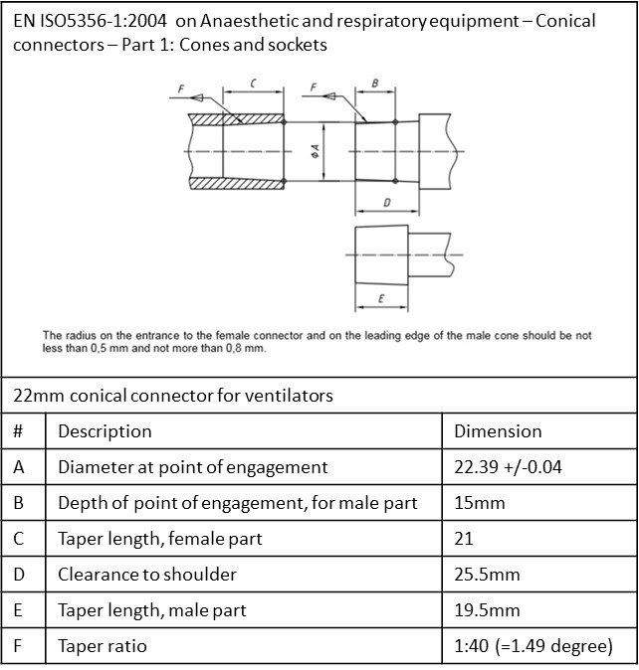

### Critical parts

The following identified the critical parts, in accordance with IEC 60601-1 and IEC 60601-2-12.

Any substitutions must meet the same rating, or better, and related standards.

|  |  |  |  |  |  |
| --- | --- | --- | --- | --- | --- |
| # | Component | Function | Manufacturer and model | Technical Rating | Standards |
| 1 | Pressure regulator | todo |  | Clean, oxygen resistant, |  |
| 2 | Solenoid valve |  |  |  |  |
| 3 | Flow restricting orifice |  |  |  |  |
| 4 | Pneumatic tubing |  |  | Oxygen resistant. Rated >10bar. |  |
| 5 | Directional valve |  |  |  |  |
| 6 | Fresh gas port |  |  | 22mm Male conical connector | IEC 5356-1 |
| 7 | Power supply unit |  |  |  |  |
| 8 | Battery |  |  |  |  |
| 9 | Pressure transducer |  |  |  |  |
| 10 | Micro-processor |  |  |  |  |
| 11 | FET transistor |  |  | Transient diode |  |
| 12 | Resistors (general) |  |  | Rated min 125mW |  |
| 13 | Capacitors (general) |  |  | Rated min 50v |  |
| 14 | Alarm sounder |  |  |  |  |
| 15 | Microphone |  |  |  |  |
| 16 | Push buttons |  |  | Rates > 10,000 cycles |  |
| 17 | LCD |  |  |  |  |
| 18 | Indicator lights (alarm, breath) |  |  |  |  |
| 19 | Case |  |  | No water ingress | IEC 60601-??? |

### Electronic design

The following diagrams (next page) suggests using a Microchip PIC controller. Any alternative microcontrollers with the appropriate number of General Purpose in/out ports and an ADC port can be used.

The Monitor instigates a serial I2C data exchange with the Controller every 50mS. It receives the set Control parameters in return. The Monitor and Controller electronics are electrically separated by at least a 4mm gap. A failure in one unit will not electrically influence the other over the I2C data lines.

Both the Monitor and the Controller (ADC) measure the pressure sensors analogue signal every 2mS.

When the monitor alarms it listens (microphone) for the speaker sound to appear. In case of a no-sound failure, the Monitor requests the Controller to sound the backup sounder.

The Controller will sound the backup sounder and display ‘Monitor Error’ if the Monitor does not poll it for 100mS.

The SLA (sealed lead acid) battery is continually float charging at 13.5V. This avoids a battery management circuitry and simplifies the design.

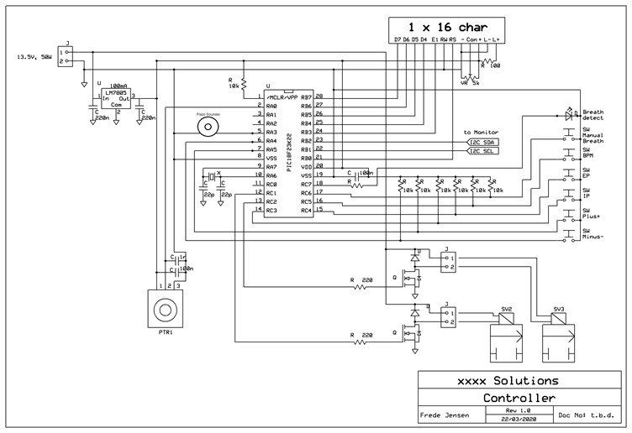

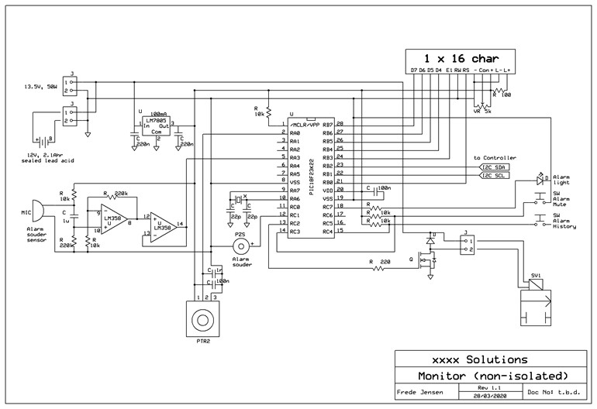

### Firmware flow – Level 1 – flow chart

The operational flow chart shown in section 1.4.3 is not complex to implement, for a skilled software/firmware developer. Although the development is an emergency, the fundamental principles of international standard IEC 62304 on medical device software life-cycle processes should be observed.

### Firmware flow – Level 2 – psudo code

To be developed. It is assumed that all standard medical software precautionary routines are used, such as 3 best of 5 tests for values stored in EEPROM cells (i.e. 1 value is stored 5 times, of which a test verifies that at least 3 are the same, before being applied).

#### Breath detection algorithm

Pressure wave breath detection uses a commonly known algorithm, which is well tested in existing marketed medical ventilators. It involves filtering/integrating the real-time patient circuit pressure into two mean values in the Controller: one is fast with a 50mS time-constant and the other is slow with a 2000mS time-constant. When the patient breathes in the circuit pressure will momentarily drop. The fast filter/integrator output will drop faster, and ‘cross’ below the slow filter output. An offset is added to the fast filter value. This offset determines the breath detection sensitivity. If the offset is too small then the algorithm risks creating false triggers (from underlying sensor/measurement noises). If the offset is too large then the algorithm risks missing a weak patient effort and the detection is delayed (less synchronized and supportive to the patient). The Controller should report the detection rate to the Monitor, for comparison and display (and alarm if they mismatch).

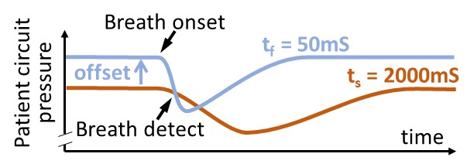

Its pseudo-code is included here for information:

BEGIN {ISR}

Save context: working, status, and program counter registers

IF interrupt = I2C buffer full

Call I2C_HANDLE

ENDIF

Pressure = ADC port value

IF pressure > 40 mbar

Call SHUTDOWN

ENDIF

Pressure_fast = Mean for last 25 Pressure values

Pressure_slow = Mean for last 1000 Pressure values

Offset = 3 mbar // Declare as a constant. Test for best result

IF (Pressure_fast + Offset) < Pressure_slow

Breath_detect = TRUE

ENDIF

[…] // Add other routines here

Restore context: working, status, and program counter registers

Clear interrupt flag

RETURN from interrupt

END {ISR}

BEGIN {MAIN}

Call CONFIG_MPU_REG

Call INITIALIZE_VARIABLES

Call INITIALISE_ISR // Set to ISR call to every 2mS

WHILE 0

Call USER_INTERFACE

[…] // Add other routines here

ENDWHILE

END {MAIN}

Routines for calculating the P_short and P_long mean values:

If using floating points math (called every 2mS):

[…]

Pressure = ADC port value

temp = P_fast/25

P_fast = P_fast – temp + (Pressure/25)

temp = P_slow/1000

P_slow = P_slow – temp + (Pressure/1000)

[…]

If using fixed points math (called every 2mS):

[…]

Pressure = ADC port value

Add Pressure to P_fast_buffer[25] // Overwrite the buffer tail, move tail pointer

P_fast = (Sum of P_fast_buffer[25]) / 25

Increment ISR_call_count

IF ISR_call_count = 40 // Only use 1 in 40 measured values

Add Pressure to P_slow_buffer[25] // Overwrite the buffer tail, move tail pointer

P_slow = (Sum of P_slow_buffer[25]) / 25

ISR_call_count = 0

ENDIF

[…]

#### Tdi and Tde detection and measurement

Similar to breath detection, maintain 2 filters/integrator in the Monitor: one is fast with a 50mS time-constant and the other is slow with a 300mS time-constant. When P_fast = P_slow then we are at a pressure plateau level. When P_fast > P_slow then we are in a Tdi phase. When P_fast < P_slow then we are in a Tde phase. Start and stop time counters at each phase change. You would average the values over the last 10 seconds of operation. Disregard any rogue values (appears more the +/-10% of the average). This will still detect a natural, gradual drift.

### Firmware flow – Level 3 – source code

The full source code is included in the Appendix 2 can be downloaded from here: www…..

### Software bug register

### Labelling

The back of the device must carry the information stipulated in regulatory requirements for ventilators. It is assumed that the regulatory qualification will be short-cut and that CE-marking might not be completed. Residual risks are described in the user manual and service manual.

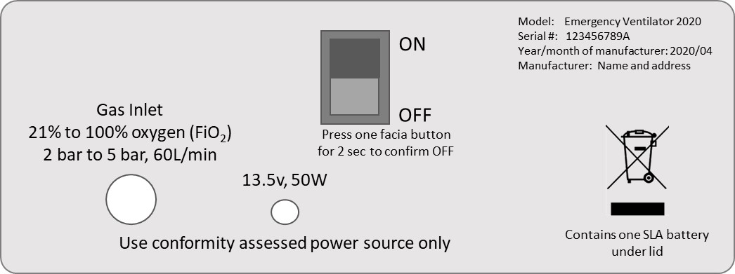

The fresh gas port is labelled ‘Gas Output’.

The exhalation control port is labelled ‘Gas Return’

The Monitor pressure port is labelled ‘Patient Pressure’.

### Durability of markings

For testing purpose, markings are rubbed by hand, without undue pressure, first for 15 seconds with a cloth rag soaked with distilled water, then for 15 seconds with a cloth rag soaked with methylated spirit and then for 15 seconds with a cloth rag soaked with isopropyl alcohol. The markings must not deteriorate.

### Packaging

Protect contain maintain contamination status. Todo

### Clinical procedure

The ventilator is designed for simplified mass-ventilation, with an operating principle that supports a deskilled (skill-divided) clinical process. This process frees-up the most skilled clinicians from hands on activities, in part to enable them focusing on a maximum number of patients, and in part to reduce their exposure to patient contaminants. In crude terms, it is easier to replace a lower skilled assistant than it is to replace a doctor.

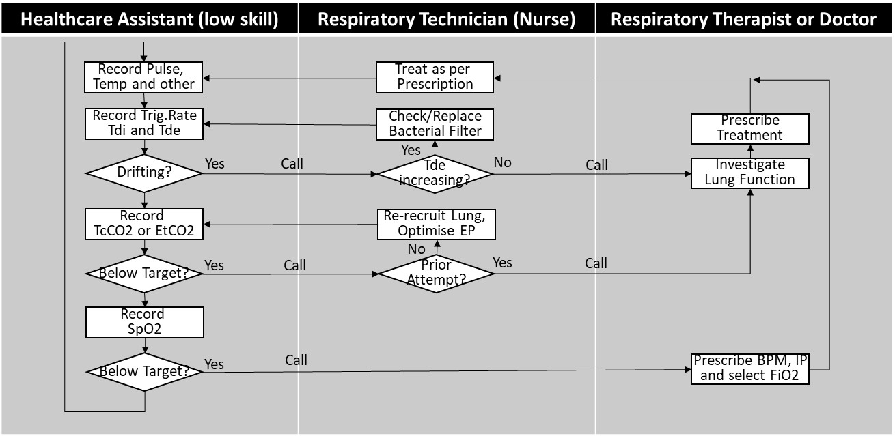

A drift in the Trigger Rate would indicate a change in the patient’s overall condition. It can be seen as a measure of stabilisation and recovery – or an indication that a rescue therapy is required.

A drift in the Tdi (IP rise time) and/or Tde (expiration wave decay time) indicates that the lung condition is changing. A shortening in Tdi would indicate a worsening of the lung condition, such as respiratory distress or a build-up of fluid or puss (which would need clearing out by a suctioning procedure). They could also indicate a problem in the patient circuit or the exhaust bacterial filter.

Selecting a different FiO2 level requires that the ventilator is temporarily disconnected from one supply and connected to another (in a matter of seconds). The Respiratory Technician should subsequently press and hold the ‘Manual Breath’ button once for 2 seconds, to re-recruit the lung.

Unless a deliberate strategy of high EP with tolerated increased blood CO2 is applied (adhere to the senior clinicians prescribed treatment), then ‘Optimise EP’ is achieved by increasing the EP by 4 or 5 mbar. Then reduce EP by 1 mbar and observe the resulting TcCO2 or EtCO2 value for 15 – 20 seconds (until settled). Repeat and observe how the CO2 elimination improves with each step, until it suddenly worsens. Return EP to the vale that produced the best CO2 elimination. Then press and hold the ‘Manual Breath’ button once for 2 seconds, to ensure that the lung is fully recruited. A simple procedural manoeuvre.

# Appendix 1 – Bill of Materials

|  |  |  |  |  |  |  |  |
| --- | --- | --- | --- | --- | --- | --- | --- |
| # | Schematic | Description | Manufacturer | Manufacturer code | Source | Link | Catalogue number |
| 1 | PR | Pressure regulator, G1/4 | SMC | ARX2-0-F02 | RS components | <https://uk.rs-online.com/web/p/pneumatic-regulators/0209187/> | RS 209-187 |
| 2 | SV1 | Solenoid valve, 2/2 NC, 2.4mm, 5W | SMC | VX212AZ1D (4mm orifice) | RS components | <https://uk.rs-online.com/web/p/solenoid-valves/8407020/> | RS 840-7020 |
| 3 | SV2 | Solenoid valve, 2/2 NC, 2.4mm, 5W | SMC | VX212AZ1D (4mm orifice)  **DRAFT – not definitive** | RS components | <https://uk.rs-online.com/web/p/solenoid-valves/8407020/> | RS 840-7020 |
| 4 | SV3 | Solenoid valve, 2/2 NC, 2.4mm, 5W | SMC | VX212AZ1D (4mm orifice) | RS components | <https://uk.rs-online.com/web/p/solenoid-valves/8407020/> | RS 840-7020 |
| 5 | FR1 | Filtered orifice restrictor, 0.025" | Air logic | F-950-73-251-B80 | Make equivalent |  |  |
| 6 | FR2 | Filtered orifice restrictor, 0.016" | Air logic | F-950-73-161-B80 | Make equivalent |  |  |
| 7 | EV1 | Exhalation control valve | Intersurgical | 1922501 | Intersurgical |  |  |
| 8 | NR1 | Directional non-return valve 22M,22M | Intersurgical | 1950 | Intersurgical |  |  |
| 9 | NR2 | Directional non-return valve 22M,22M | Intersurgical | 1950 | Intersurgical |  |  |
| 13 | PTR1 | Pressure tranducer, 40mbar, amplified | Freescale Semiconductor | MPXV5004GP | RS components | <https://uk.rs-online.com/web/p/differential-pressure-sensor-ics/7191166/> | RS 719-1166 |
| 14 | PTR2 | Pressure tranducer, 40mbar, amplified | Freescale Semiconductor | MPXV5004GP | RS components | <https://uk.rs-online.com/web/p/differential-pressure-sensor-ics/7191166/> | RS 719-1166 |
| 15 | U1 | t.b.d. | t.b.d. | t.b.d. | t.b.d. |  |  |
| 16 | U2 | t.b.d. | t.b.d. | t.b.d. | t.b.d. |  |  |
| 17 | PSU | External power supply, 13.5v, 4A (50W) | t.b.d. | t.b.d. | RS components | <https://uk.rs-online.com/web/p/desktop-power-supplies/7649113/> | RS 764-9113 |
| 18 | BATT | Sealed Lead Acid, 12v, 2.1Ahr | Yuasa | NP2.1-12 | RS components | <https://uk.rs-online.com/web/p/lead-acid-batteries/0597813> | RS 597-813 |
| 19 | SPK | Mylar speaker, 1W, 8 ohm | t.b.d. | t.b.d. | RS components | <https://uk.rs-online.com/web/p/speaker-drivers/6284529/> | RS 628-4529 |
| 20 | PZS | Continuous Piezo Buzzer | t.b.d. | t.b.d. | RS components | <https://uk.rs-online.com/web/p/piezo-buzzer-components/6173097/> | RS 617-3097 |
| 21 | MIC | Electret microphone, pcb mount | t.b.d. | t.b.d. | RS components | <https://uk.rs-online.com/web/p/condenser-microphone-components/7243125/> | RS 724-3125 |
| 22 | LCD1 | Alphanumeric LCD, 1 Row by 16, green | Fordata | FC1601E01-FHYYBW-51LE FC | RS components | <https://uk.rs-online.com/web/p/lcd-monochrome-displays/1253297/> | RS 125-3297 |
| 23 | LCD2 | Alphanumeric LCD, 1 Row by 16, green | Fordata | FC1601E01-FHYYBW-51LE FC | RS components | <https://uk.rs-online.com/web/p/lcd-monochrome-displays/1253297/> | RS 125-3297 |
| 24 | TB1 | Air Hose Clear Polyurethane 8mm OD, 2m length | RS components | RS 917-2404 | RS components | <https://uk.rs-online.com/web/p/air-hose/9172400/> | RS 917-2404 |
| 25 | TB2 | Air Hose Clear Polyurethane 6mm OD, about 30cm length | RS components | RS 917-2400 | RS components | <https://uk.rs-online.com/web/p/air-hose/9172400/> | RS 917-2400 |
| 26 | TB3 | Air Hose Clear Polyurethane 6mm OD, about 30cm length | RS components | RS 917-2407 | RS components | <https://uk.rs-online.com/web/p/air-hose/9172407/> | RS 917-2407 |
| 27 | CN1 | Elbow 22F, 6mm, 22M | Intersurgical | 1893 |  |  |  |
| 28 | CN2 | Elbow 22M, 22F | Intersurgical | 1992 |  |  |  |
| 29 | CN3 | T-piece 22M, 6mm, 22F | Intersurgical | 1963 |  |  |  |
| 30 | CN4 | Straight connector, 8mm to 1/4 thread | RS components | RS 916-0729 | RS components | <https://uk.rs-online.com/web/p/pneumatic-straight-fittings/9160729/> | RS 916-0729 |
| 31 | CN5 | Elbow connector, 6mm to 1/4 | RS components | RS 176-1404 | RS components | <https://uk.rs-online.com/web/p/pneumatic-straight-fittings/1761404/> | RS 176-1404 |
| 32 | CN6 | Elbow connector, 6mm to 1/8 | RS components | RS 916-0858 | RS components | <https://uk.rs-online.com/web/p/pneumatic-elbow-fittings/9160858/> | RS 916-0858 |
| 33 | CN7 | Elbow connector, 6mm to 1/8 | RS components | RS 916-0858 | RS components | <https://uk.rs-online.com/web/p/pneumatic-elbow-fittings/9160858/> | RS 916-0858 |
| 34 | CN8 | T-connector, 6mm, 6mm, 1/8 | RS components | RS 916-0808 | RS components | https://uk.rs-online.com/web/p/pneumatic-t-fittings/9160808/ | RS 916-0808 |
| 35 | CN9 | Elbow connector, 6mm to 1/8 | RS components | RS 916-0858 | RS components | <https://uk.rs-online.com/web/p/pneumatic-elbow-fittings/9160858/> | RS 916-0858 |
| 36 | CN10 | T-connector 6mm, 4mm, 6mm | RS components | RS 176-1376 | RS components | <https://uk.rs-online.com/web/p/pneumatic-tee-tube-to-tube-adaptors/1761376/> | RS 176-1376 |
| 37 | CN11 | Elbow connector, 6mm to 1/8 | RS components | RS 916-0858 | RS components | <https://uk.rs-online.com/web/p/pneumatic-elbow-fittings/9160858/> | RS 916-0858 |
| 38 | CN12 | Elbow connector, 6mm to 1/8 | RS components | RS 916-0858 | RS components | <https://uk.rs-online.com/web/p/pneumatic-elbow-fittings/9160858/> | RS 916-0858 |
| 39 | CN13 | Elbow connector, 6mm to 1/8 | RS components | RS 916-0858 | RS components | <https://uk.rs-online.com/web/p/pneumatic-elbow-fittings/9160858/> | RS 916-0858 |
| 40 | CN14 | Elbow connector, 6mm to 1/8 | RS components | RS 916-0858 | RS components | <https://uk.rs-online.com/web/p/pneumatic-elbow-fittings/9160858/> | RS 916-0858 |
| 41 | CN15 | Pneumatic Quick Connect Coupling Brass 1/4 | RS components | RS 667-1730 | RS components | <https://uk.rs-online.com/web/p/pneumatic-quick-connect-couplings/6671730/> | RS 667-1730 |
| 42 | ENC | Metal case 280 x 210 x 106 | t.b.d. | t.b.d. | RS components | <https://uk.rs-online.com/web/p/instrument-cases/7694902/> | RS 769-4902 |

# Appendix 2 – Source code

Insert source code, the whole 20 – 30 pages of it